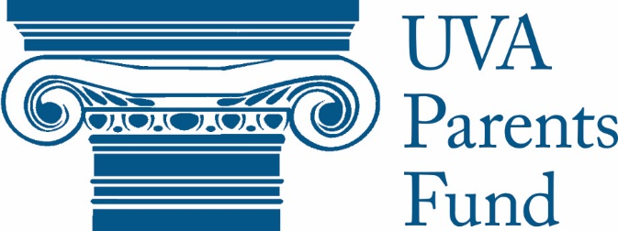

2020-2021 Grant Application

Please read this application and “Terms and Conditions” on our website carefully. Applications that are incomplete or do not follow this template will be disqualified from consideration. Groups may submit ONE APPLICATION ONLY. If you are requesting funds for multiple projects or events, prioritize them within your application. Please note that, for the 2020-2021 academic year, the Parents Fund will hold two grant cycles, one in Fall 2020 and the other in Spring 2021. See our website for further information.

- Organization Mission/Purpose: Summarize your organization’s mission and its main activities/functions in three sentences or less.

- Project Overview: Summarize your project’s goals/objectives in five sentences or less. Please also answer each of the following:

- What are the dates of your event/project?
- What is the approximate number of students you expect to attend, participate, or be impacted by this event or project?
- Describe your plan to measure the project’s effectiveness toward meeting your goals and objectives.
- Explain why this project is important, and its potential benefit to the University community in three sentences or less.

- Financial Overview/Structure:

- How is your organization funded (e.g., dues, admission, StudCo, grants, etc.)?
- If this is a new organization or project, what are your long-term plans for financial viability/longevity?
- Have you applied for other funding for this particular project or for the organization in general? If so, from where, and for how much? (Please list all, even if you haven’t received funding or are still waiting to hear back.)

- COVID Compliance: Given the University’s current health regulations, how are you pivoting or re-configuring this year to make your project or event compliant with the new rules and current health circumstances?
I affirm that I have read all of the Parents Fund Grant terms and conditions on the UVA Parents Fund website and will adhere to them if selected for a Parents Fund Grant. I also affirm that my organization will follow all of the University’s COVID-compliance regulations for all on- and off-Grounds events affiliated with this grant application.

_______ Initial here

***Failure to initial here will disqualify your application***

